# Project proposal for

# DST &Texas Instruments Inc.

# India Innovation Challenge Design Contest 2016

# Anchored by IIM Bangalore

# SMART NAVIGATION SYSTEM FOR THE VISUALLY IMPAIRED

# SSN COLLEGE OF ENGINEERING

|  |  |  |  |  |
| --- | --- | --- | --- | --- |
| Name | College ID/Roll No. | UG/PG | Course/Branch | Semester |
| NAVEEN NARAYANAN | 312214106066 | UG | BE/ECE | 5 |
| V.PRAKASH | 312214106073 | UG | BE/ECE | 5 |
| RAVISHANKAR | 312214106085 | UG | BE/ECE | 5 |
| P.SIVASANKAR | 312214106102 | UG | BE/ECE | 5 |
| S.SOMASUNDAR  K.VIMAL RAJ | 312214106104  312214106125 | UG  UG | BE/ECE | 5 |
| (FACULTY)  Dr R.RAJAVEL  Dr S.JOSEPH GLADWIN |  |  |  |  |

# Project Abstract

Visually challenged people all over the world face difficulties in navigation, particularly in an unknown environment. They depend on others or canes to guide them to their requisite destination. However these ordinary canes are not efficient enough for their hassle free movement. This project aims to develop a smart navigation system using the current technology for visually impaired to reduce their dependency on others.

This system will provide vocal assistance and obstacle free movement to visually challenged people using sensors and a microcontroller which is connected to the Wi-Fi system .Based on the location of the person and the nearby obstacles, a voice message is sent to the device which can be heard through a headphone.

# Keywords:

Wi-Fi

Microcontroller

Sensors

Voice Message

Smart Cane

Headphone

# Team Members – Roles & Responsibilities

Teams must share the list of all members and explain their role in the team as per following category

* Marketing
* Technical,
* Operations, &
* Any other role(s) as applicable

Teams to provide justification for each team member's role and cite examples as required to support your reasoning.

|  |  |  |  |
| --- | --- | --- | --- |
| **S.No.** | **Student Member Name** | **Role (Choose one of the following – Marketing, Technical, Operations & Other Roles as applicable)** | **Justification** |
| 1 |  |  |  |
| 2 |  |  |  |
| 3 |  |  |  |
| 4 |  |  |  |
| 5 |  |  |  |

# Market Analysis

Teams to provide a detailed study about the customer needs [in context of India] leading to identification of the problem being solved which coversthe Total Addressable Market (TAM), Serviceable Addressable Market (SAM), study of existing solutions [Competition]and opportunities for enhancing/improving the solution leading to the proposed solution.

Teams to validate their analysis with usinggraphs, illustrations and quantitative data from different sources as applicable.

1. Customer Need Identification - <Teams to present thier case & Share information>
2. Serviceable Addressable Market (SAM) Identification & Justification - <Teams to share details of their SAM and support with analysis as applicable>
3. Product Differentiation w.r.t. Competition& Justification - <Teams to Highlight the differentiated featues of their product w.r.t. to completion/existing product with justification>
4. Understanding of your customer & user- <Teams to identify their customer & user and share their product positioning to enable ease of adoption for both of these >

***Note:*** Users refer to people using the product/service, and a customer is one who pays for the product/services***. Depending on product both could be same or different.***

1. Distribution Channel Identification - <Teams to share how would you deliver the product/service to the customers/users>

# Proposed Design

Objective –

The objectives of this project are to:

1. Setup a database server that stores the different audio files with directions to different places.
2. Place WI-Fi routers at different points and connect them to the server through a common switch.
3. Pre configure the server with the MAC addresses of the router
4. Place the sensors along with the microcontroller on a cane to detect obstacles.
5. Design a smart standalone system with a 3.5mm audio jack.

# Proposed Solution

* 1. Block Diagram -

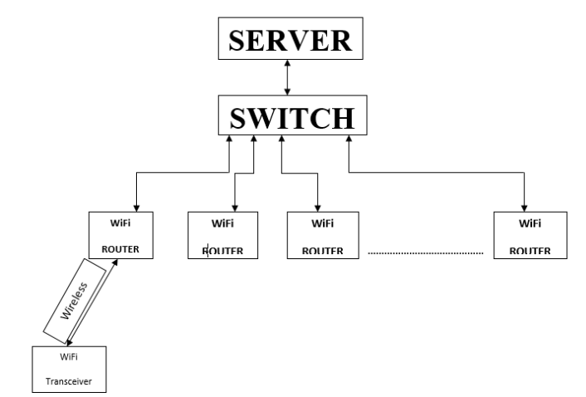

Component Used -

|  |  |
| --- | --- |
| TI Part Number  (link all the parts to their respective product page on the TI website) | How is it being used in the proposed solution? Explain its role/functionality |
| Part 1 TDC100 | Ultrasonic sensor-Used to detect nearby obstacles |
| Part 2 CC3100 MOD www.ti.com/product/cc3100MOD/description | Microcontroller |
| Part 3 |  |
| Part 4 |  |
| Part 5 |  |

|  |  |
| --- | --- |
| Non - TI Parts | How is it being used in the proposed solution? Explain its role/functionality |
| Part 1 PC |  |
| Part 2 WI-Fi Router DLink |  |
| Part 3 |  |
| Part 4 |  |
| Part 5 |  |

# Innovativeness of the Proposed Solution

Teams have to explain the uniqueness/differentiation of their proposed solution with respect to the existing competition in the current scenario. Teams can differentiate their proposed solution on the following vectors – size, power, performance, cost, functionality& others as applicable

# Impact of the proposed solution

Teams have to explain the impact of their proposed solution on the customer/relevant industry and Justify with data as applicable.

# Feasibility

Teams have to explain the practicality of the idea to be converted into a product in current market scenario in India. Teams can share their brief plan for manufacturing the product in India. Teams can refer to generic product development lifecycle to form their plans.